This is an intro to synthesis activity, but it could be fun on a half-day or something of that sort. I realized that students don’t think they come into the class with research skills, so I created this lesson so they could realize that they use somewhat decent research skills every day when dealing with their drama. Also, for those hard-to-reach kids who don’t seem to care about AP or the skills, they will at least care about their drama, so they need these skills.
Prompt 1: In your group, write a letter to Marc that will help him with his situation.

The other day, Marc Tetreault and his girlfriend, Shirley Positive, got in a rather large fight. Now, they seemed to be getting along for the tenure of their relationship—2 weeks—but since the fight a lot of information has been revealed, and now Marc needs to make a decision about his relationship.

So, read the following sources and accompanying contextual information carefully. Then, in a letter that synthesizes from at least three of the sources for support, evaluate the most important factors Marc should consider when deciding whether or not to continue to date Shirley Positive.

Prompt 2: In your group, write a letter to Marc that will help him with his situation.

The other day, Marc Tetreault and his girlfriend, Shirley Positive, got in a rather large fight. Now, they seemed to be getting along for the tenure of their relationship—2 weeks—but since the fight a lot of information has been revealed, and now Marc needs to make a decision about his relationship.

So, read the following sources and accompanying contextual information carefully. Then, in a letter that synthesizes from at least three of the sources for support, develop a position about how Marc should handle his situation with Shirley from here.

Remember: Always evaluate sources!
Sources:
- Tweet from Shirley that arrived the night after her fight with Marc:“It’s just doesn’t seem worth it anymore.”

- Danielle is a credible source for accurate school gossip, but she is also over-dramatic: she is always involved in some sort of school drama—yes, even the club—she has actually told Marc: “I actually was told by Sally” [the stupidest, most unreliable jerk in the school] “that Shirley was cheating on you with Joe.”

- Zach, he’s an interesting character, but none-the-less he is good friends with Shirley. (By the way, he actually likes her as well.) He revealed to Danielle, as they sat together on the bus, that: “I was talking to Shirley the other day, and she is convinced that Marc is cheating on her because Marc has been on the phone with Lindsey for the last two nights. I guess she is going to break up with him.”

- Shirley Positive happens to be absolutely stunning. (i.e. She’s a fly hunnie.)

- Shirley Positive also has had 6 boyfriends in the last 3 months, but before that she dated one kid for 3 years (8th -10th grade).
- Marc himself was overheard saying, after one week of dating:“I really enjoy hanging out with Shirley; she’s cute, funny, and all around awesome. I love her.”

- Mr. Freitas has publically told his classes:“I don’t think dating in high school is very wise. In fact, unless you can picture yourself comfortably married within a year, you shouldn’t be dating at all no matter what your age.”

- The following was posted on Marc’s Instagram four nights ago: 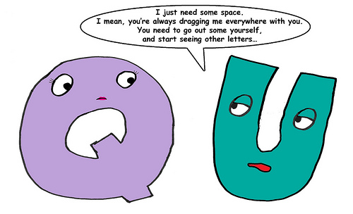
Created by Timm Freitas
The Garden of English

Image taken from https://supersushichan.wordpress.com/2010/05/12/q-and-u-break-up/

