The Garden of English
AP English Language
Propaganda Assignment:
Propaganda is information that is especially biased and is used to promote or publicize a particular cause or point of view. It is often conotatively considered negative and misleading. For this next assignment, you will be required to—both with a partner and individually—research an oppressive and/or corrupt regime (private/public). (You can look at policies, individuals, corporate practices, etc.) You will need to find information that supports the actions of the corrupt/oppressive regime and information that attacks said regime. With the information you find, each of you must make a propoganda flyer (that could hypothetically be distributed to the community at large) that is meant to incriminate, combat, and/or dismiss the alternate side’s views; one of you will create a flyer that is pro-regime, and one of you will create a flyer that is anti-regime. Once you have completed your flyer, you must exchange it with your partner, and your partner will have to write a well-developed, two-paragraph rhetorical analysis that explains how the flyer is constructed to effectively display its message to the public. This assignment must be submitted electronically. If you produce hard copies, you need to arrange for them to be scanned/photographed. If you complete the project in a non-digital format, it is your responsibity to make sure that all elements are electronically legible. It is also your responsiblity to make sure that your files are uploaded as PDF or Word documents; I will not be able to access any other file types. If you wait until after school on the [insert date] to upload this and you experience any technical difficulties, this is your fault and will result in a failing grade; all difficulties must be brought to my attention before the end of class on the 60th. Your work should be finished before the [insert date]; however, I am giving you until that night to upload it because of my gracious heart. THIS ASSIGNMENT MUST BE complete by 11:59PM on [insert date].

Research (Planning: No Points)
The first part of this project that you must complete is the research. You are required to find at least FOUR (4), but no more than six (6), sources that relate to your oppressive/corrupt regime(s). It is strongly suggested that you find two sources that are pro (regime/corporation/special interest) and that you find two that are anti (regime/corporation/special interest) (or 3 a piece if you are using 6 sources). You may consider exploring examples of corporate, governmental, or social corruption/oppression. Once you have some research that you know will be the basis for your flyers, create MLA works cited entries for each source. Use OWL and/or Easybib.com. YOU ARE RESPONSIBLE FOR MAKING SURE THAT ALL OF THE CORRECT INFORMATION IS ACCOUNTED FOR AND ACCURATELY FORMATED/PRESENTED.

Flyer (Individual Grade: 40pts)
You and your partner must choose to represent one side of the corruptive/oppressive issue that you are exploring. Ultimately, when you put your work together, there will be one pro-regime flyer and one anti-regime flyer. You should create your flyer using Microsoft Publisher, Adobe Photoshop or Indesign, or any other digital tool that may assist you. You may also work by hand. Should you choose the latter option, you must make sure that you can upload your image in manner that allows me to clearly read and observe your work. You must choose who will represent what side. Once you have made that choice, you must produce a flyer that includes the following:
- At least one eye-catching and perhaps startling (yet school appropriate), pertintent visual. (5pts)
- Information that identifies and contextualizes the urgency of the problem at hand. (10pts)
- At least two references to source materials (research) must show up in your document. Make sure to cite the source material with either parenthetical citations or footnotes. (10pts)
- At least one reference to source information that is unethically synthesized. (If you only include two referecnes to your research, one must be unethically synthesized.) (5pts)
- A clear call to action as to how this situation must be best handled by the people you are trying to persuade. (10pts)

Rhetorical Analysis (Individual Grade: 30pts)
Once you have completed your flyer, you must exchange it with your partner. Once you have obtained your partner’s flyer, you must write a two paragraph rhetorical analysis in response to it. Please make sure that your analysis covers the following criteria:
- You comment on at least three persuasive elements of your partner’s flyer. (12 pts)
- You explain how each of the elements you choose to explore informs the reader of the flyer’s message and persuades the reader to take action in response to the situation. (18pts)
Works Cited (Group Grade: 20pts)
As a group, you are going to generate an MLA works cited in response the the research you completed. Please make sure to note the following:
A Garden of English Production: GardenofEnglish2019©
- You are responsible for accurately documenting your source material. Feel free to use Easybib.com; however, Purdue’s OWL is the sure-fire way to complete this.
- Your works cited must have the words “Works Cited” in the top middle (formatted correctly) and alphabetized sources with hanging indents. The text should be 12 point font, Times New Roman or Footlight MT.
- Any formating issues with the works cited page will result in a full loss of all of the 20 points associated with this task. There is A TON of information about MLA formating available on the internet and in my classroom; this information is also often accompanied by examples. You have to make sure that you know how to complete proper documentation tasks.

Presentation (Group Grade: 10pts)
Once you have completed the flyers, rhetorical analyses, and works cited page, you must compile your information and submit it on Moodle. There will be a heading on your course’s Moodle page that reads “Final Propoganda Project.” I strongly suggest that you have both group members upload the document, just in case one member has technical difficulties. Before you upload your project, however, you will want to create a coverpage and organize your information as detailed below:
- You must have a title page that in some way identifies the “corruptive/opressive” issue at hand. This title page must also include a picture and the names of the indivudals that make up the partner group.
- You should follow this with the individual propoganda flyers. Make sure that you include your name on your piece of propoganda. The propoganda flyer is an individual grade; see assignment details above.
- Your flyers should be followed by the individual rhetorical analyses. Make sure that you write a two paragraph rhetorical analysis of YOUR PARNTER’S work. Make sure your name is on what you write. It does not matter whose rhetorical analysis come first; however, you may wish to consider matching the order of these assignments with the order of the propoganda flyers.
- An MLA works cited including your four sources: 2 pro, 2 con.
A Garden of English Production: GardenofEnglish2019©
A Garden of English Production: GardenofEnglish2019©

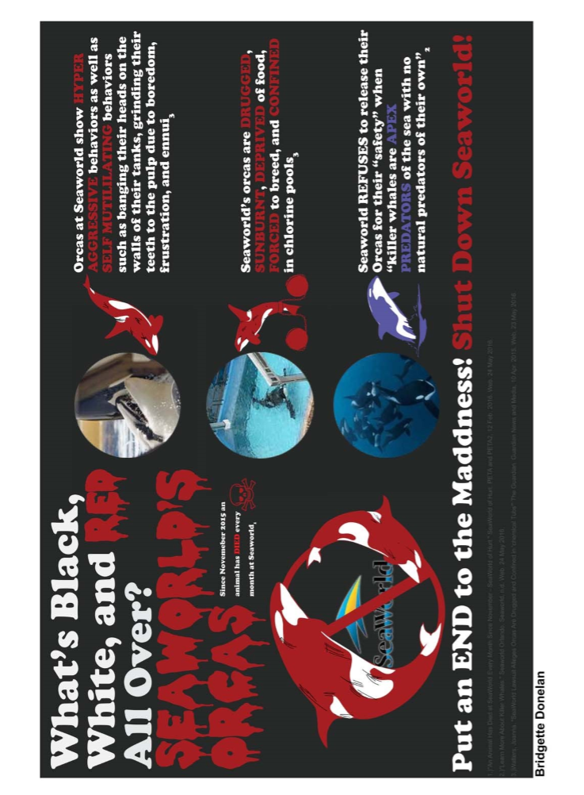
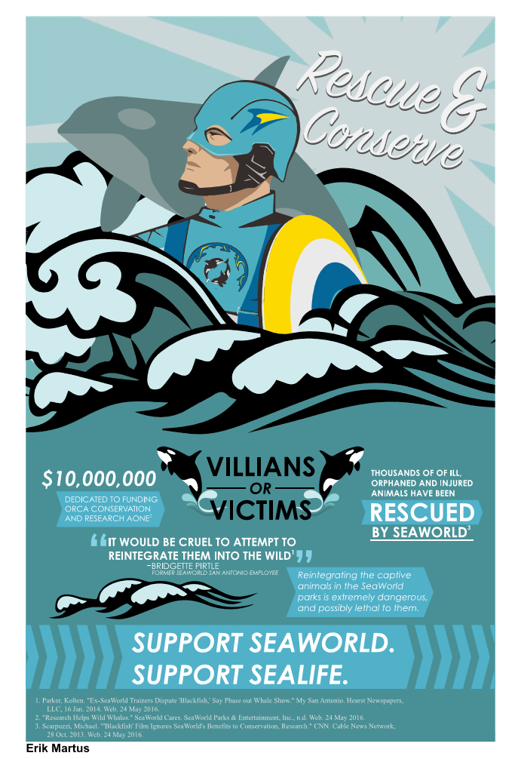
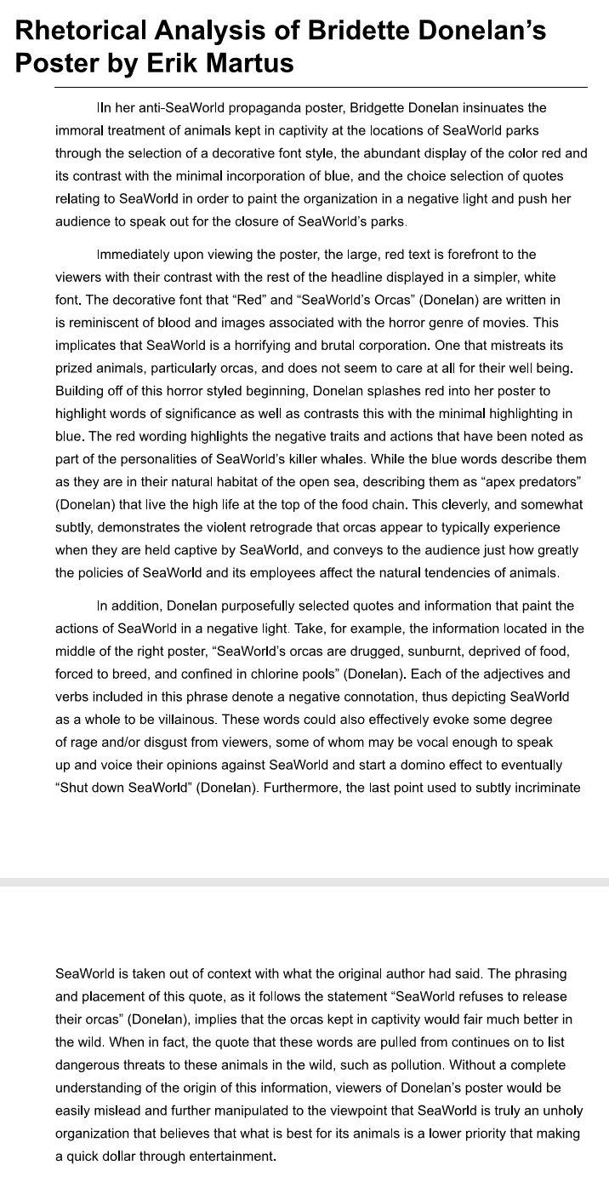
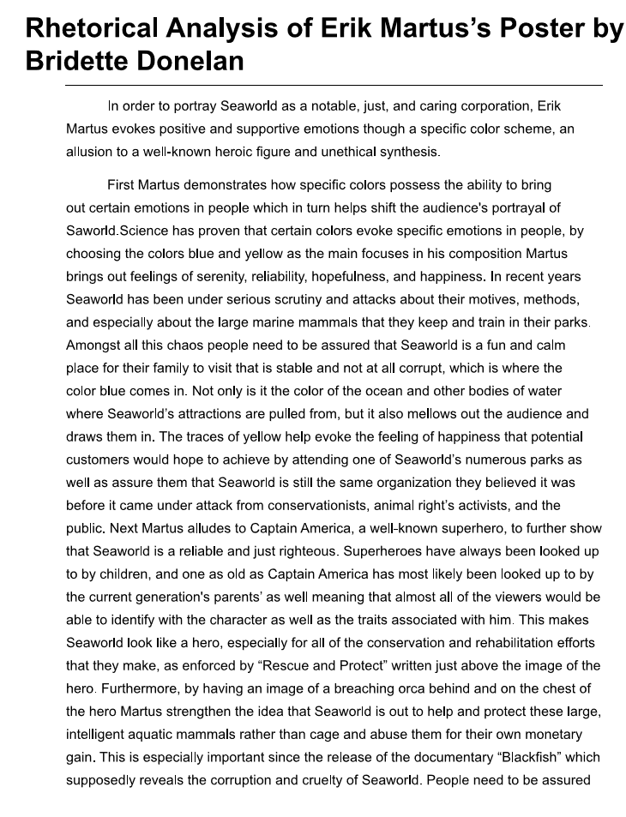
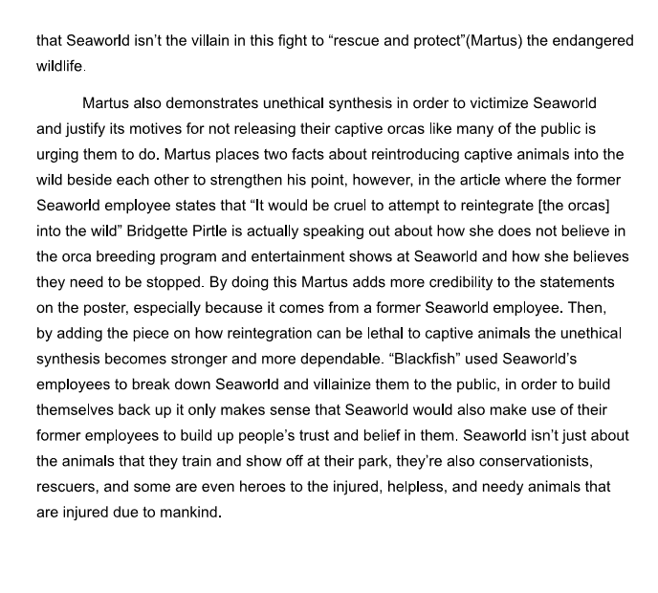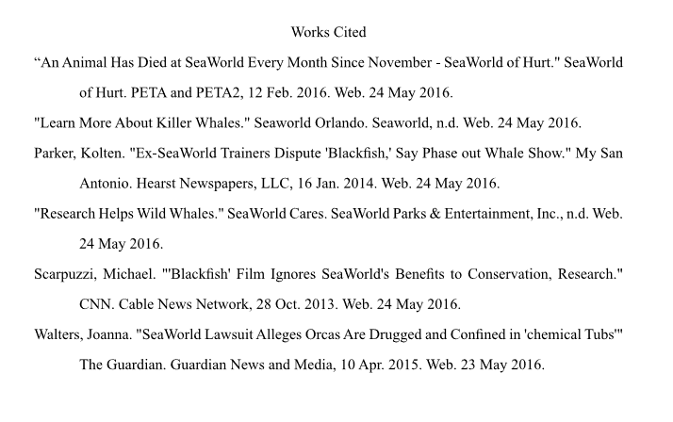

Modified from an original Google definition
This is an all or nothing grade. You will either get the 10 points or you won’t. There is no partial credit here.

